-+



**Project Report on developing a Mobile Application**

**For**

**Marbeck Records**

Submitted To: Submitted By:

Prof. Fadi Fayez

Gagandeep Singh (13477667)

**Table of Contents**

**List of Images** 3

**List of Tables** 4

**Executive Summary** 5

**Chapter 1: Introduction** 6

**1.1. Background** 6

**1.2. Current situation and Purpose** 6

**1.3. Scope** 7

**1.3.1. Scope in our project** 7

**Chapter 2: Business Case** 8

**2.1. Core team** 8

**2.2. Measurable organizational value (MOV)** 9

**2.3. Identify Alternatives** 9

**2.3.1. Alternative 1: Creating a Mobile Application** 10

**2.3.2. Alternative 2: Migrating current website to Cloud platform** 11

**2.3.3. Alternative 3: Re-engineering the current website** 12

**2.4. Feasibility Analysis** 13

**2.4.1. Metrics used for Alternative comparison** 14

**2.4.2. Feasibility analysis for Alternative 1** 14

**2.4.3. Feasibility analysis for Alternative 2** 16

**2.4.4. Feasibility analysis for Alternative 3** 17

**2.5. Total Cost of Ownership & Benefits** 18

**2.6. Analyse & Purposed Alternative** 19

**2.7. Summary** 20

**Chapter 3: Project Charter & Plan** 21

**3.1. Project Stakeholder** 21

**3.2. Measurable Organizational Value (MOV)** 22

**3.2.1. Steps to achieve perfect MOV** 22

**3.3. SDLC Methodology** 24

**3.4. Project Schedule Summary** 25

**3.4.1. Work Breakdown Structure** 25

**3.4.2. Sample Activity on Node Network diagram** 27

**3.4.3 Gantt Chart** 28

**3.5. Communication Plan** 28

**3.6. Resources Required** 30

**3.6.1. People** 30

**3.6.2. Project Team** 31

**3.6.3. Technology** 31

**3.6.4. Facilities** 32

**3.7. Assumptions & Risks** 32

**3.7.1. Assumption used to develop estimates** 32

**3.7.2. Key Risks and impact** 33

**3.7.3. Resolution of Risks** 34

**3.8 Summary** 34

**Chapter 4: Conclusion** 35

**References** 36

**APPENDIX A** 38

**APPENDIX B** 41

**APPENDIX C** 44

# **List of Images**

1. Image 1: Internal & Stakeholders in Marbeck Records 22

2. Image 2: Prototyping model 24

3. Image 3: WBS of Marbeck records 26

4. Image 4: AON Diagram 28

5. Image 5: Percentage of Mobile technology usage in current scenario 32

6. Image 6: Upfront cost for Alternative 1 38

7. Image 7: Upfront cost for Alternative 2 39

8. Image 8: Upfront cost for Alternative 3 40

9. Image 9: Revenue & Benefits or Alternative 1 41

10. Image 10: Revenue & Benefits or Alternative 2 42

11. Image 11: Revenue & Benefits or Alternative 3 43

12. Image 12: Gantt chart for Alternative 1 44

13. Image 13: Gantt chart for Alternative 2 45

14. Image 14: Gantt chart for Alternative 3 46

# **List of Tables**

1. Table 1: Team members and their role 9

2. Table 2: Alternatives 10

3. Table 3: Feasibility analysis 13

4. Table 4: Internal & External Stakeholders 21

5. Table 5: MOV using Metric Value 24

6. Table 6: Activity on Node 27

7. Table 7: Communication plan table 29

8. Table 8: People included in project 30

9. Table 9: Project team 31

10. Table 10: List of Initial risks 34

# **Executive Summary**

Marbeck is a well-recognized organization, which is running its music store from past 82 years, but to compete with the upcoming technology and to increase customers and sales, Marbeck needs modification in its system to meet the requirement. In this report, three alternatives provided to Marbeck organization such as shifting current website to cloud, Re-engineering the current website and creating mobile app for the organization. After, analysing the three alternatives based on MOV, scope and feasibility analysis mobile app is the accurate option for the organization to meet the requirement. Furthermore, cost benefit analysis; also support developing a mobile app, as it is cheap and the reliable option for Marbeck to enhance their business. The sample of work break down structure is also included to show the schedule of the work. On the other hand, some of the initial risks are also included.

# **Chapter 1: Introduction**

## **1.1. Background**

According to (Marbeck Records, 2017), Marbeck is one of the oldest and well reputed music store in Auckland since 1934.The company got the exponential growths in 78s because of the 78 records all the shipment was sold within 3 days which basically strengthen the backbone of the business. Then in 1997 Marbeck expanded its store and was considered as biggest music store of New Zealand with two floors equipped with various types of music which was handled by 40 staff members. Furthermore, in 1998 Auckland power crises effected numerous business and forced the retailers to relocate their business that effect the Marbeck as it relocates to the Queen arcade base. In 2007 Roger observed number of changes in the music world and decided to sold the Marbeck and shift the business from retail to wholesale music agent in New Zealand. Then in 2013 an opportunity came to return Marbeck to the family and they purchased it back and the business ran on the same track as it was running before delivering the finest flavours of music to its customers. It has wide variety of catalogues like pop, world music, jazz etc. Marbeck staff is fully experienced and deals with the number of customers across the world this company has its online website also marbecks.co.nz for online purchase. This store is currently look after by Roger son Logan it is now fourth generation family business which is delivering quality music from past 80 years.

## **1.2. Current situation and Purpose**

Marbeck store which is currently running successfully and a website for online purchase. This music store has fully updated catalogues of music and it delivers music overseas besides locally. This is one of the popular music company in entire New Zealand. This company have its store running successfully and a website for online purchase. In this project, in order to meet with the modern era mobile app and to increase sales volume and revenue of the company we intend to develop a new mobile App for Marbeck. This is since nowadays people are bound to the technology and mobile is the best medium to interact with the customers. This is considered a strategic move by the company besides it can be seen as essential step toward increasing the business value.

Mobile app will increase awareness of the company’s products range and can be considered as a powerful tool to spread the business to the digital world since mobile is a major mode of communication. This apps can create a good communication channel between company and its current and potential customers. Currently few music stores have mobile apps so this will help the target company to gain more accessibility and improve its reputation in the cut throat competition.

## **1.3. Scope**

Planning a scope in simple word is the other part of planning a project, which includes the proper documentation and conclusion of goals, features, deliverables, functions, tasks, and total costs (Marchewka, ITPM, 2003). There are certain steps or works to define the project scope. Those are:

* Objective of project
* Goal of project
* Major tasks in project
* Budget
* Resources in project

### **1.3.1. Scope in our project**

In this project, our scope is to enhance the overall sale of the organization by introducing a new mobile app. So, we limit the scope to mobile platform business activities such as customer registration, payments, search, display, communications, and App design. No reporting or business intelligence reports are within the scope of this project.

# **Chapter 2: Business Case**

Business case ensure that the investment is justified in the strategic direction of the company and benefits it will deliver. It provides resources, benefits, cost and set of options for decision maker and funders. It also help to measure the success so that the project meets the requirement (Business cases, benefits, costs, and impact, n.d.).

This chapter explains the format and content of a business case and the different process involved in its creation. Business case, which contain all the essential components like core team, MOV, analysing the methodology, feasibility analysis and cost, benefit analysis. In this chapter, the business case has developed for developing a mobile app that can enhance the business and customers of Marbeck organization.

## **2.1. Core team**

Rather than imposing, all the work responsibilities on a single individual to complete the project a core team should be recruited for a project that can work together as a team. The core team should consist of managers, business experts and designers these people can analysis the project carefully to meet the requirement of the customers. Moreover, a core team should have a IT specialist team that can understand the opportunities, limitations and risk associated with IT (Marchewka, ITPM, 2003).

**Responsibilities of Team members:**

* Work as a team
* Create emergency operation plan
* Discuss every step with project manager
* Act as a positive agent

**Team members in our project are:**

Table 1: Team members and their role

|  |  |
| --- | --- |
| **Position** | **Role** |
| Project Manager | In the development of the mobile app, also a project manager is the main individual that ensure that the project is delivering on time within budget and manage the relationship between client and stakeholders. (Project manager duties, n.d.) |
| Designer | Designer is a person that gather the requirement and use case modelling by outlining the system functionality. |
| Application Developer | These individual works in a team to collect the ideas from the public or review from the customers. Then they narrow these ideas to create a flow chart to include every aspect in the app. App developer are also familiar with the coding language and how to apply in an efficient way to create an app. After the deployment, there duties are to test the app to remove bugs before its launch. (Application developer job descrption , n.d.) |

## **2.2. Measurable organizational value (MOV)**

IT project or any project should be aligned according to the goal, mission, and objectives of the organization. It means any alternative idea provided by the core team should have clear purpose a fulfil all the goals according to the strategy of organization. According to IT project methods, the goal and success measurement is referred as Measurable organizational value. In MOV the following points are must to be included (Marchewka, ITPM, 2003):

1) Measurable: Proper measurement of everything gives more focus in the actions of project team. This will help to avoid doing extra work and wastage of time.

2) Value: Resource and time should provide the value to the organization.

3) Agreement: All the stakeholders included in the project, they must agree to the MOV of project. In first attempt, it is very hard to agree everyone, but as time passes and efforts makes that possible.

4) Verifiable: The MOV must be verified at the end to figure out that project is a success or failure.

More details of MOV is explained in Chapter 3, 3.2 Measurable organizational organization.

## **2.3. Identify Alternatives**

In any business case, there must be alternative projects as well so that the selected project must have reason, why it has been selected among other alternatives?

An Alternative in project is the mixture of resources, risks, budget, and time that grant to achieve the expected results in comparison to the project dead-line. It can also be creating the same project in a different way with using the same old resources but operating in a total new project environment. We can also state them as an option for the project (McConnell, 2010). Alternative analysis must include the summary of what it suggests and some points about why this alternative is not being selected.

In our business plan, total 3 alternatives are considered. Those are:

Table 2: Alternatives

|  |  |  |
| --- | --- | --- |
| **Alternative Option 1** | **Why Yes?** | **Why Not?** |
| Create a Mobile Application | * Increase in Economy * Increase in Customers * Competing with current technology | * Risk factors * Compatibility issues * Total new user interface |
| **Alternative Option 2** | **Why Yes?** | **Why Not?** |
| Shift the current running website to Cloud computation | * Highly available * More secure environment * Helpful in disaster recovery | * Cyber attacks * Lack of support * Current business is low |
| **Alternative Option 3** | **Why Yes?** | **Why Not?** |
| Re-engineer the current website | * To give more security to payment methods * For resolving the customer complaints | * Might start from nothing * Time consuming * Budget issues |

### **2.3.1. Alternative 1: Creating a Mobile Application**

This alternative is giving the idea to the organization to create a mobile application for both iOS and android users. As per the current technology, mobile application is very handy and everyone need everything on their hands. Now, there are many benefits of having a mobile application like increase in economy, increase in the new customers and competing with current technology.

In creating the mobile applications, we are going to follow the SDLC prototype model. Prototype models are the best for the software development or application development. In SDLC prototyping model the under developed behaviour of application is displayed, to check whether the output can be good or not but the final and actual product will be different from the prototype (Verma E. P., 2015)

Phases followed in the Prototyping model:

**1. Requirement Gathering**: In this Phase, the entire requirement is being gathered. This phase is the responsibility of product analyst team. In this requirement phase, details of design and security can be neglected. For example: all resources, software, and hardware.

**2. Quick Design**: This is the phase where initial prototype of the system is developed. The software that is being developed can be differ from the original software or application. The main purpose of this phase is to have the similar look of the application.

**3. Building Prototype**: This phase will give the similar look for the final application that has to be designed by gathering the information from the quick design.

**4. Customer Evaluation**: This is the evaluation phase for the developed prototype application. The outside customers will check the working of application and gives the feedbacks to the team. The feedback is properly organized for the improvement of the application.

**5. Refining prototype**: The revision and enhancement of the application is done in this phase. The feedback from the customer evaluation is used in this phase. All the issues occurred during evaluation phase are refined in this phase. All the changes are accepted and again new prototype is made as shown in figure.

**6. Engineer product**: After getting all the reviews and feedbacks from the above phases the prototyped application is sent to the development team.

### **2.3.2. Alternative 2: Migrating current website to Cloud platform**

In this alternative, client is already having a live online shopping website for buying CD/DVD’s but this alternative gives an idea of shifting it to cloud based platform. Cloud based websites are in trend right now making websites highly available to the users. The main benefits why we gave this idea because of high availability, more secure and main role for the disaster recovery.

Now, there are certain stages or methods that we have to follow for web development. Those are:

**1. Analysis**: Analysing the right factors are so necessary. Researchers will analyses the requirement of the market and what trend is getting followed which will give a better and user friendly website to the customers.

**2. Initial Design**: After analysing all the requirements the report is sent to the designers and the developers for creating an initial design. The brainstorming of the ideas is also processed in this stage. In cloud website, initial design is same like normal design.

**3. Approval of design**: Initial design need to be approved by the project manager to send it for the developing. If project manager wants some changes to be done in the design, then after redesigning the approval is sent for the development.

**4. Web Development**: This stage is the coding part of the website. All the features that are analysed and sent to the design phase will be carried out. For the cloud web development developer need more time to code because cloud technology is a new era technology very less people are aware of that even the developers.

**5. Prototype and testing**: In this stage the website is set to put online but in a closed alpha or beta mode. Alpha and beta closed mode means it will be online but will available for few number of users to use it. Also, within the prototype the testers will test the website for any sort of bug or error. If no error comes and everything went fine, then the website is taken out from the closed alpha mode and sent to the open beta mode to check whether the current website can handle the load of the thousands of users and one point of time. For cloud services, load balancers and auto scaling plays major role.

**6. Execution**: After testing the website from errors and bugs, website is ready to be launched and set to go. The launching can be done on a bigger or on a smaller scale depending upon the budget of the company.

**7. Maintenance**: The maintenance is necessary for the website as it is required for other software’s or applications. In maintenance mode, the will check the behavior of the website. Any reviews and feedbacks are also considered.

### **2.3.3. Alternative 3: Re-engineering the current website**

This alternative will provide a robust outlook to the organization as this will give enhancement in the facility of the website. This process will start from the initial stage because the organization do not have the codes and the password so the implementation will be from the scratch.

To implement the SDLC process will be followed as this process will take time and all the stage should be configured properly to get a better result. There are number of stages that are covered before reaching to the final point.

**1. Analysis**- This stage is analysing stage in which idea is analysed as per the alternative the idea for re-engineer is popular in the market to enhance the facilities of the website and developers also show interest to implement this.

**2. Initial Design**- In this stage the web designer and developer will work together to give best output the website as this is the initial stage where website is starting building. Re-engineer the website is a difficult task a starting from scratch so the web designer and developer brainstorms their minds to give better ideas for designing.

**3. Design Approval**- This stage is like a result for the wed designer and the managers approve developer as here the design. To see that if it is meeting the requirement of the organization expectation or not.

**4. Web development**- In this stage the website development process starts as with the help of the initial design the coder does the process starts and coding. After this frequent revision is also done in this stage to check the efficiency of the web site.

**5. Prototype**- In this stage the web designer and the developer will present the website and it will be tested on two different sets of testing techniques.

* Alpha- If the website will be used by the public it will test by this testing technique to see the interest of the users.
* Beta-This test is used check the efficiency of the website that it handles the traffic or it can handle the huge number of users.

**6. Launching**- In this stage the website is launched for the user after testing. If the organization have good budget they can advertise the website to increase the users and revenue of the company.

**7. Maintenance**- This stage is a vital stage as this will never end as every time if there is any problem with the website the maintains team will look after it to protect it from the bugs.

## **2.4. Feasibility Analysis**

Each alternative should be analysed on the perspective of feasibility. This concept basically deal with the scanning of every alternative that it is worth doing it or not and with this process those alternatives that are not correct for the project are ruled out from the list (Marchewka, ITPM, 2003)

Feasibility should be calculated in term of:

1. Economic Feasibility- This Feasibility is performed to test the alternative but not only cost, the existing funds and resources of the organization as well as benefits provided by the chosen alternative need to be considered.
2. Technical Feasibility- This feasibility needs to consider wide spectrum of topics like does the current infrastructure supports the alternative and need of new technology, availability of new technology and skill and experience of the IT staff.
3. Organizational Feasibility-This feasibility considers impact on organization in form of acceptability, impact on job, effect on overall business.
4. Schedule Feasibility- This feasibility is performed analyse the time taken by the project to be completed.

This analysis is done to see the stronger and weaker part of the project and with this analysis we can finds various activities that can help to achieve the result. The nature and the component of the feasibility studies totally depends upon the area in which analysed project is implemented.

Table 3: Feasibility analysis

|  |  |
| --- | --- |
| **Feasibility Analysis** | **What to do?** |
| Evaluation of technological and system capabilities/requirement. | Types of data, methods and software that are necessary in the project, name of Data Sources. |
| Evaluation of Economical capabilities/requirement. | All the cost that will be used for implementation of the project. |
| Evaluation of the organization. | How the organization user will adopt the new implementation. |
| Evaluation of schedule | Time management |

After deciding three alternatives for the Marbeck organization to enhance their overall growth, we will do feasibility analysis for each alternative.

Alternative 1: Creating a new mobile App. from scratch

Alternative 2: Shifting the current running website services and enhancements to cloud Technology Company (outsourcing)

Alternative 3: Re-engineer the business processes of current website. This includes Business process evaluation, Business process by eliminating waste management and integrating certain Business processes, Business process testing.

### **2.4.1. Metrics used for Alternative comparison**

**2.4.1.1. Payback analysis**- This is used to determine the length of time required to get the investment back from the project (Payback period, n.d.).

Payback Period = Initial Investment / Return (or benefit) per year

**2.4.1.2. Return on investment**- This is a term which indicate the total profit from the investment. It measures the effectiveness of investments and used for evaluation of economic centre (ROI - Return On Investment, n.d.).

- ROI= Net Profit / Investment * 100

**2.4.1.3. Breakeven analysis**- This term is used to determine the cost structure and it tells the number of items that need to be sold to cover the cost or make profit. This is also used to analysis the business plan to see how practical the plan is and whether it is practical to pursue it or not (Martin, 2014).

Break Even Point = Fixed price / (Sale Price-Variable price)

### **2.4.2. Feasibility analysis for Alternative 1**

This alternative is to create a mobile App for the organization to expand their growth in the cut throat competition. This analysis will be done on different factors.

**2.4.2.1. Technical Feasibility**- This feasibility is used to evaluate different technology and resources required for app development. For developing a app various factors are considered.

- Platform that will be suitable now-days android and apple are the major platform so build an app in C++, Java and swift code programming language are required. these types of software will be required.

- Software – To create App on android eclipse and android studio software are used and in Iso XCode is used.

- Skilled staff that can develop an app and troubleshoot it easily.

**2.4.2.2. Organizational Feasibility**- This feasibility is used to analyse that how the users in the organization will adapt the innovation. As mobile app, is a new technology it will create many changes in the organization users have be ready to accept the new challenge and organization should provide support to the users to accept the changes. According to Marina (in Reddy, 2015),

- Provide proper training so that the staff have enough skills to get familiar with the mobile App technology.

- Motivate the staff.

- Share the success rate of the innovation among the staff members

**2.4.2.3. Schedule Feasibility**- This feasibility is used to analysis the time taken by the project to be completed. For Gantt chart, image reference is in Appendix C.

**2.4.2.4. Economic Feasibility analysis**- This feasibility analysis is the major as in the initial stage the cost and other resources analysis is done. This analysis gives the brief idea that the organization have enough funds and resources that can easily support the innovation and can maintain that for long run. For App development, the base price which is used now-days is approximately $27,595.

Three popular techniques that can assess the economic feasibility.

* Payback analysis- We have also calculated the time period when will the organization will get all the income back.

Payback Period = Initial Investment / Return (or benefit) per year

Payback period after 3rd year = 27,595/26,280 = 1.05 years

* Return on investment- For the mobile application development, we have calculated ROI of 3rd year because in first two year it is not possible that an organization will get back all its investment.

Formula- ROI= Net Profit / Investment * 100

= 26280/27595*100

= 95.23%

*ROI is always calculated in percentages.

* Breakeven analysis- After analysing the all the area, we have deduced the breakeven point.

Fixed cost/year = $500

Variable Cost/product= $30

Sale price/product = $35

Break Even Point = Fixed price / (Sale Price-Variable price)

= $500 / ($35-$30)

=100

Therefore, this value suggest that organization need to sell approx. 100 products to cover the cost that spent in each year.

### **2.4.3. Feasibility analysis for Alternative 2**

This alternative is to shift the existing website to the cloud to provide a secure platform and increase the efficiency of the company. This analysis is done on various factors.

**2.4.3.1. Technical feasibility**- This feasibility is used to analyse the technology and resources that are required for shifting an existing app to the cloud.

- Selecting platform is one of the main task now-days AWS is best platform as it provides bests service and security.

- Resources like domain and web hosting will be required.

- Skilled staff will be required that will included like cloud architecture, cloud web designer and cloud web developer.

**2.4.3.2. Organizational Feasibility**- This feasibility is used to analyse that how will the new innovation will be adopted by the users in the organization. Shifting an existing website to cloud is a different task and how it will impact the organization will create new challenges and organization should have set of rules that can be used to overcome that.

- Proper guidance and training should be given to the employee about cloud infrastructure.

- Share the awareness of the success rate among the employee.

**2.4.3.3. Schedule Feasibility**- This analysis is done to find out time taken by the project to be completed. For Gantt chart, image reference is in Appendix C.

**2.4.3.4. Economic Feasibility**- This feasibility analysis is done to get the initial cost that will be required for the project implementation. This analysis gives brief idea to the organization that this much amount of funds is need to support the project. For shifting the current website to the cloud with AWS platform will cost approximately $22,720.

Three popular techniques that can assess the economic feasibility.

* Payback analysis- We have also calculated the time period when will the organization will get all the investment back.

Payback Period = Initial Investment / Return (or benefit) per year

Payback period after 3rd year = 22,720/5,956.80

= 3.81 years

* Return on investment- For shifting the current website to cloud technology the ROI is deduced from 3-year time period because it is not possible that an organization will get all its investment in first two years.

Formula- ROI= Net Profit / Investment * 100

= 5956/22720*100

= 26.21%

*ROI is always calculated in percentages.

* Breakeven- After analysing the all the area, we have deduced the breakeven point.

Fixed cost/year = $1070

Variable Cost/product= $30

Sale price/product= $35

Break Even Point = Fixed price / (Sale Price-Variable price)

= $1070 / ($35-$30)

=214

So, this value suggest that organization need to sell approx. 214 products to cover the cost that spent in each year.

### **2.4.4. Feasibility analysis for Alternative 3**

This alternative is provided to the organization to modify the current website if the organization have password and portal if not the website will be constructed from the scratch. This analysis is done on various factor to see that it is feasible to do this task or not.

**2.4.4.1. Technical feasibility**- This feasibility analysis is done find the technology and resources will be required for re-engineering the website.

* Asp.net platform will be used to build the website.
* My Sql database will be need to store the data of the website.
* Css and Xml programming language will also be used.

**2.4.4.2. Organizational Feasibility**-This feasibility analysis is done to analysis the how will the users in the organization will adopt the new innovation. Re-engineering a web site is a challenging task. So, organization should provide proper plaining for adoption of new techniques.

* Proper training session should be conducted to give awareness about new features in the website.
* Create better communication among team member regarding project scope, requirement and status.

**2.4.4.3. Schedule Feasibility**- This feasibility analysis is done to find the accurate time taken by the project to be completed. For Gantt chart, image reference is in Appendix C.

**2.4.4.4. Economic Feasibility**- This feasibility is used to determine the initial cost that is required by the organization for re-engineer the business process of current website. For Re-engineering the website now-days it costs approximately $23,950.

Three popular techniques that can assess the economic feasibility.

* Payback analysis- We have also calculated the amount of time it will take till the organization will get all the investment back.

Payback Period = Initial Investment / Return (or benefit) per year

Payback period after 3rd year = 23,950/8,280

= 2.82 years

* Return on investment- For the website Re-engineer we have followed the same criteria as in the other alternatives and calculated the ROI of 3rd year to check the amount of investment received by the organization.

Formula- ROI= Net Profit / Investment * 100

= 8280/23950*100

= 34.57%

*ROI is always calculated in percentages.

* Breakeven analysis- After analysing the all the area, we have deduced the breakeven point.

Fixed cost/year = $2350

Variable Cost/product= $30

Sale price/product= $35

Break Even Point = Fixed price / (Sale Price-Variable price)

= $2350 / ($35-$30)

=470

Therefore, this value suggest that organization need to sell approx. 470 products to cover the cost that spent in each year.

**2.5. Total Cost of Ownership & Benefits**

To invest on an IT project must take all the cost that will be included in that development of the application. TOC stands for total cost of ownership this term has gained attention in recent years it deals with all the cost of acquiring, development and maintaining. TCO includes such costs.

1. Up-Front cost- It includes all the initial installation cost of software, hardware and telecommunication equipment is which are used in the initial stage of the project.
2. Ongoing cost- These are the cost, which will be there until the project ends like salaries, training, upgrade and maintenance.
3. Indirect Cost- This cost is generally arising when a risk occurs and extra income is used.

It is very important to analyse that if TCO goes beyond the original purchase. TCO give all the information of the possible cost impacts. While preparing the business case it is very crucial to document all the data sources, assumptions and methods for degerming the various cost (Marchewka, ITPM, 2003).

Now, the images in Appendix A will explain total cost of ownership and Appendix B will explain Benefits per alternative.

## **2.6. Analyse & Purposed Alternative**

Alternative 1, that is creating a mobile application for Marbeck Records will help in improving the business in every aspect. As in Image 5 all, the upfront costs are mentioned stating that for the initial year this amount of budget is required to develop the application. Now if we look at the cost benefit analysis (refer to Feasibility analysis alternative 1), the payback period calculated comes out to be 1.05 years, this means from the 3rd year of business the whole money invested in the business will be pay backed by the net profit. In addition, ROI shows that expected value of the product delivered is 95.23%. It means the amount we invested into the project will give us the return on this percentage. Finally, from the breakeven analysis, results show that if company sells 100 products per year it can cover the fixed cost that project demands every year including maintenance and other charges.

Alternative 2 was to shift the current website to the cloud. This will enhance the feature of the website and make it more secure. In image 6, we have also deduced the upfront cost of the whole project. Moreover, the feasibility analysis is done to test this alternative on all the factors like technical, schedule, economical and origination feasibility. We have also calculated the ROI as 26.21%, this percentage tells us that with this rate we will get our investment back. Payback analysis which is 3.81 years it means in 3rd year the organization will start earning its investment and Breakeven point is 214 it means that this amount of the items should be sold in one year to cover all the investment (for more details see the economic feasibility of alternative 2).

Alternative 3 was to Re-engineer the current website but the organization do not have the coding and passwords so this process will start from the scratch. This process will take huge investment and time to enhance the website features. In image 7, we have calculated the upfront cost of the whole project. Moreover, the entire feasibility test is done and for more details, ROI is calculated which is 34.57% with value the organization will get its investment back. Payback analysis is 2.82 years it means in 2nd year the organization will start earning its investment and Breakeven point is 470 it means this number of items should be sold every year to cover all the investment (for more details navigate to the economic feasibility of alternative 3).

So, in conclusion if we analyse the cost benefit analysis and other aspects like profits and revenue, Alternative 1: creating a mobile application is giving Marbeck records a better result in increasing the customers towards the business among all the other alternatives mentioned. Other aspects that make Alternative 1 as best is because the next generation is mobile generation. Everybody wants everything on hands. Alternative 2 is also good but for only when customer rate is too high because developing website using cloud technology means that business needs the website to be highly available to the customers and is being frequently used. Alternative 3 is reengineering the website will cost more money and even the payback period and ROI are not at that level that it will affect and give benefit to the business.

## **2.7. Summary**

In this chapter, business case of the project is explained with all its components. Components like persons included in core team, MOV, feasibility analysis, cost benefit analysis, total cost ownership and risk assessment. Business case make the picture clear to select the appropriate alternative for the organization that can enhance the productivity. In the next chapter 3, project charter of the selected alternative is created.

# **Chapter 3: Project Charter & Plan**

Project charter is a document that consist project scope, objectives, resources, risk and list of stakeholders. It helps the project manager to identify the problem at the early stage before the project starts (Billows, 2016). In this chapter, Project Charter of Marbeck organization is explained which includes the list of stakeholders, scope, project schedule summary, Resources required, risk and project administration plan. This charter explains the whole picture of the project and its approach it also describes the roles and responsibility of each stakeholder.

## **3.1. Project Stakeholder**

Stakeholders is a person or group of people or organization that have interest in your project that may be affected directly or indirectly by the outcome of the project. Stakeholder may include team members, sponsors, organization, and people outside the organization as well. The number of the stakeholder increases and decrease as per the project and different stakeholder have different requirement and expectation from the project (Usmani, n.d.).

The table below shows the comparison between the internal and external stakeholder (Surbhi, 2015)

Table 4: Internal & External Stakeholders

|  |  |  |
| --- | --- | --- |
| **Basis of comparison** | **Internal Stakeholder** | **External Stakeholder** |
| Who are they? | These individuals and people are the part of the organization | These individuals are not the part of the organization but got effected by certain activities of the project |
| Nature of Impact | Direct | Indirect. |
| Who are they? | They basically server to the organization | They get impact by the organization work |
| Employed by the entity | Yes | No |
| Responsibility of the company towards them | Primary | Secondary |
| Includes | Sponsor, internal customer or client, Program manager, project team and management | Government, social media, supplier, local communities and external customers or client |

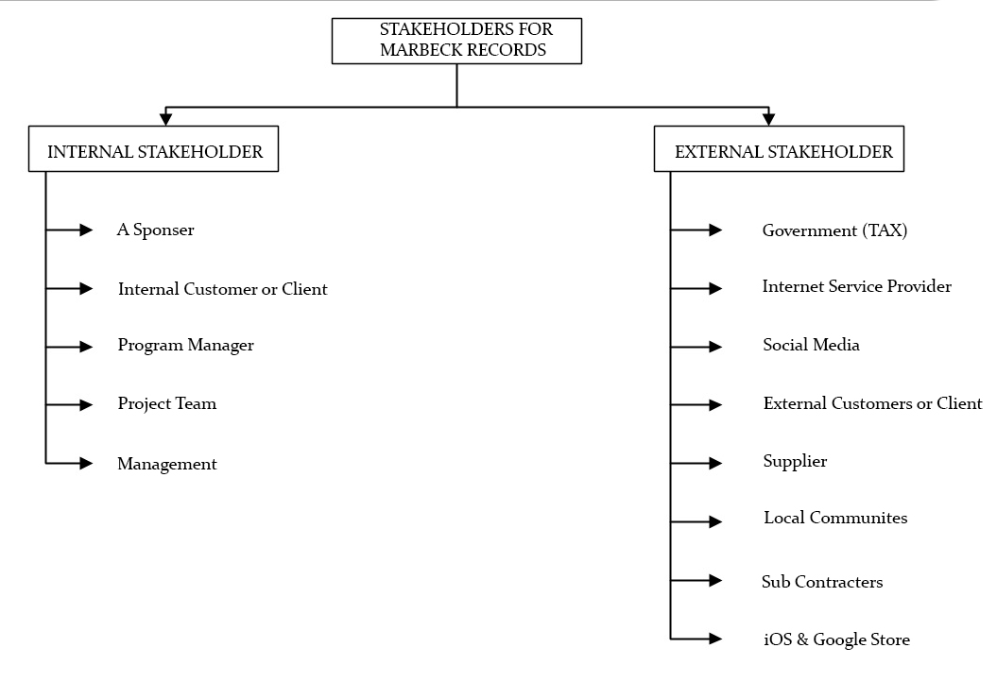

Image 1: Internal & Stakeholders in Marbeck Records

## **3.2. Measurable Organizational Value (MOV)**

IT project or any project should be aligned according to the goal, mission, and objectives of the organization. It means any alternative idea provided by the core team should have clear purpose a fulfil all the goals according to the strategy of organization. According to IT project methods, the goal and success measurement is referred as Measurable organizational value (Marchewka, ITPM, 2003).

**3.2.1. Steps to achieve perfect MOV**: In order to achieve the well-behaved MOV team must need to follow some steps. These steps include the area of impact, value of impact and developing appropriate metric.

#### **3.2.1.1. Identifying desired area of Impact**

This first step is to identify the desired area of impact. It suggests what the expectations of stakeholders towards the project is (Marchewka, ITPM, 2003). For example: some of the stakeholders prefer the satisfaction of customer, some prefer financial profit value. The important areas of impact are as follows

* Strategic impact
* Customer impact
* Social impact
* Financial impact
* Operational impact

In our project area of impact are:

Strategic: The current era is depending on mobile applications in which everyone wants everything on their hands. So strategically mobile application is needed for Marbeck.

Customer: Joining more and more customers to the business always help in growing the business.

Financial: Increase in customers will help to increase the financial values of the company

#### **3.2.1.2. Identifying desired value of the project**

After the identification of desired area of impact, the next part is to identify the value pf the project (Marchewka, ITPM, 2003). To identify the value of IT project four important questions that are important to take care of:

1) Better: improving condition or improving the capability

2) Faster: Increase the speed, efficiency

3) Cheaper: Reducing costs

4) Do more: Expanding and growing business

In our project the only desired value of project is to “Do More”. The reason behind selecting Do More is to improve the business economically along with increase in number of customers.

#### **3.2.1.3. Developing appropriate metric**

By developing it, company will know that project is a success and the money that is being invested is paying off. The metric includes representation in consideration of Money, Percentage and Number of customers increased or Numeric values of customer visited.

Table 5: MOV using Metric Value

|  |  |
| --- | --- |
| **Year** | **Measurable Organizational Value** |
| 2017 | Hike in profit by 10% and increase in active number of customers by 2000 members |
| 2018 | Hike in profit by 20% and increase in active number of customers by 9000 members |
| 2019 | Hike in profit by 30% and increase in active number of customers by 14,000 members |

## **3.3. SDLC Methodology**

In creating the mobile applications, we are going to follow the SDLC prototype model. Prototype models are the best for the software development or application development. In SDLC prototyping model the under developed behaviour of application is displayed, to check whether the output can be good or not but the final and actual product will be different from the prototype (Verma P. , 2015).

Phases followed in the Prototyping model:

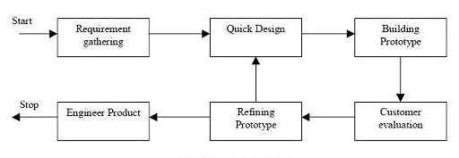

Image 2: Prototyping model

Requirement Gathering: In this Phase, the entire requirement is being gathered. This phase is the responsibility of product analyst team. In this requirement phase, details of design and security can be neglected. For example: all resources, software, hardware.

Quick Design: This is the phase where initial prototype of the system is developed. The software that is being developed can be differ from the original software or application. The main purpose of this phase is to have the similar look of the application.

Building Prototype: This phase will give the similar look for the final application that has to be designed by gathering the information from the quick design.

Customer Evaluation: This is the evaluation phase for the developed prototype application. The outside customers will check the working of application and gives the feedbacks to the team. The feedback is properly organized for the improvement of the application.

Refining prototype: The revision and enhancement of the application is done in this phase. The feedback from the customer evaluation is used in this phase. All the issues occurred during evaluation phase are refined in this phase. All the changes are accepted and again new prototype is made as shown in figure.

Engineer product: After getting all the reviews and feedbacks from the above phases the prototyped application is sent to the development team.

## **3.4. Project Schedule Summary**

### **3.4.1. Work Breakdown Structure**

Work Break down structure defines the work that are required to be carried out to produce the product deliverable. It represents the hierarchical subdivision of the project into phases and then into tasks and further the number of task are decomposed into activities to make the project manageable. WBS is a building block of project management, which includes all the work including planning, cost, effort estimation, scheduling, and resource allocation (Work break down structure, n.d.)

Reasons for creating WBS (T.Rajani Devi, V.Shobha Reddy, 2012):

1. It enables the project scope clear to the stakeholders.
2. It helps to explain the control point and project milestone.
3. It gives accurate estimation of cost, risks, and time.
4. Helps to assign duties among employees.

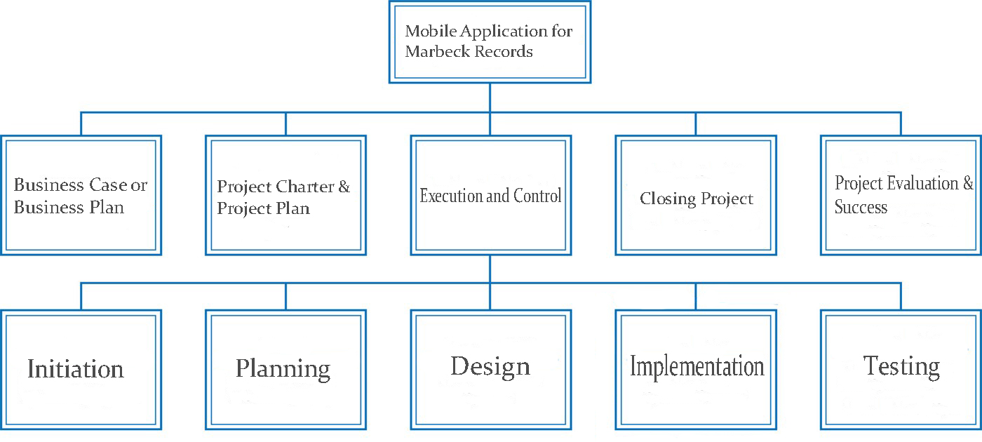

Image 3: WBS of Marbeck records

-0.0 Mobile Application for Marbeck records

+1.0 Business case or Business plan

+2.0 Project charter & Project plan

+3.0 Initiation

-4.0 Planning

+4.1 Create fundamental scope statement

+4.2 Determine Project team

+4.3 Project team kick-off meeting

+4.4 Develop project plan

+4.5 Submit project plan

+4.6 Milestone: Project plan approved

+5.0 Design

+6.0 Implementation

+7.0 Testing

+8.0 Closing project

+9.0 Project evaluation & success

### **3.4.2. Sample Activity on Node Network diagram**

Activity on nodes is a precedence diagramming method in project management. It use boxes to describe various activities, these activities are further connected from staring to end to define dependences between schedule activities. Each node is coded with number or letter that correspond to the activity on project schedule.

Table 6: Activity on Node

|  |  |  |  |
| --- | --- | --- | --- |
| Activity | Description | Duration | Predecessor |
| A | Create fundamental scope statement. | 2 | - |
| B | Determine project team. | 3 | A |
| C | Project team kick-off meeting. | 1 | A |
| D | Develop project team. | 3 | B,C |
| E | Submit project plan. | 5 | C |
| F | Milestone: Project plan approach. | 3 | E |

Critical path:-

1. A+B+D+F=11
2. A+C+E+F=9
3. A+C+D+F=11

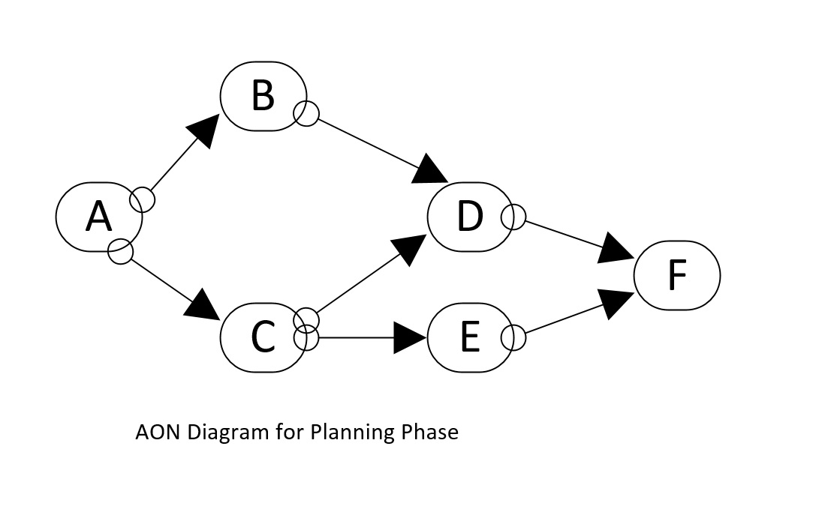

Image 4: AON Diagram

### **3.4.3 Gantt Chart**

This feasibility is used to analysis the time taken by the project to be completed. Gannt chart provide proper information of all the task done by whom and time taken to complete the task. Gantt chart for alternative 1 is reffered to Appendix B.

## **3.5. Communication Plan**

Communication is the most important medium used to share vital information among the employee. Imagine in a large organization the stakeholders in the project have different varieties of technologies, some can share drives, and others do not. Some have access to video conferencing and others have only telephone and email facilities. Therefore, it is important to be effective and project information must be communicated using a same set of technology (Communications Management Plan, n.d.).

According to the Marbeck organization, the communication and technologies are based on several factors that may include stakeholder communication requirement, available technologies and organization policies and standard.

Marbeck maintains a share point platform within PMO, which will keep records of all the reports update and conduct project communication. With this platform, the organization members and the stakeholders can share the project data and can easily communicate at any point of time. If some stakeholder does not have access with share, point can be connected through the website the organization will provide unique username and password to be connected and these stakeholders can see the project communication and documentation on website. Marbeck also maintain a software license for MS project software and all the project team are responsible for developing, maintain and communicating schedule using this software. Pert chart is also used for communicate the schedule to the stakeholder and the project schedule will be maintained on share point and website.

Table 7: Communication plan table

|  |  |  |  |  |
| --- | --- | --- | --- | --- |
| **Type** | **Objectives** | **Medium** | **Team Included** | **Format of Document** |
| Kick-off meetings | Review the main objectives and propose the project team | Face to face meetings | * Project Sponsor * Project team * Stakeholders | Soft copy via email |
| Project Team meetings | Inspect status with the team | * Face to face meetings * Video or audio conference call | * Project team | Soft copy via email |
| Design meetings | Examine and design solutions for the project | Face to face meetings | * Technical staff | Soft copy via email |
| Project status meetings | Update status of project to management | * Face to face meetings * Video or audio conference call | * Project management office (PMO) | Soft copy via email |
| Status reports | Update status of project along with activities, cost, and issues | * Email | * Project Sponsor * Project team * Stakeholders * Project management office (PMO) | Soft copy via email |

## **3.6. Resources Required**

### **3.6.1. People**

Table 8: People included in project

|  |  |
| --- | --- |
| **People** | **Responsibilities** |
| Project Manager. | In the development of the mobile app, also a project manager is the main individual that ensure that the project is delivering on time within budget and manage the relationship between client and stakeholders. (Project manager duties, n.d.) |
| Project Analyst | Project analyst is employee that work under the project manager and work analytics duties. It analysis the feasibility analysis, budget and documents regarding project so that project meets the requirement of the project (Project analyst job duties, 2014). |
| Designer. | Designer is a person that gather the requirement and use case modelling by outlining the system functionality. |
| Application Developer. | These individual works in a team to collect the ideas from the public or review from the customers. Then they narrow these ideas to create a flow chart to include every aspect in the app. App developer are also familiar with the coding language and how to apply in an efficient way to create an app. After the deployment, there duties are to test the app to remove bugs before its launch. (Application developer job descrption , n.d.) |

### **3.6.2. Project Team**

Table 9: Project team

|  |  |  |  |
| --- | --- | --- | --- |
| Role | Name | Email | Phone |
| Sponsor | P. White | [p.white@abc.com](mailto:p.white@abc.com) | +64204444109 |
| Manager | G. Brown | [g.brown@abc.com](mailto:g.brown@abc.com) | +64204102569 |
| Designer | D. Black | [d.black@abc.com](mailto:d.black@abc.com) | +64215647898 |
| iOS Developer | J. Mehra | [j.mehra@abc.com](mailto:j.mehra@abc.com) | +64236687554 |
| Android Developer | G. Singh | [g.singh@abc.com](mailto:g.singh@abc.com) | +64223366489 |
| Customer | Marbeck Records | [m.logan@marbeckrecords.com](mailto:m.logan@marbeckrecords.com) | +64202345645 |
| Maintenance | J. Mehra | [j.mehra@abc.com](mailto:j.mehra@abc.com) | +64236687554 |

### **3.6.3. Technology**

After analysing the statistics, IOS and android are the leading platform to develop a App in current era.

Programming language- C++, Java and swift code are the programming language that are required.

Software -In android eclipse and android studio and in iOS XCode is used.

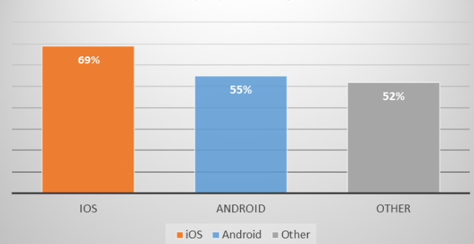

Image 5: Percentage of Mobile technology usage in current scenario (iOS and Android, While going through numbers, 2015)

### **3.6.4. Facilities**

1. Easy to operate.
2. Highly available.
3. More secure.
4. Free of cost.

## **3.7. Assumptions & Risks**

### **3.7.1. Assumption used to develop estimates**

To develop estimates numerous terms are analysed to get the full estimate of an alternative. For developing a mobile app first, we must follow the MOV steps to get the area of impact that in which perspective this alternative will be beneficial for the organization and then the desired value of project is analysed so that our project is better, faster and cheaper. Then the main part is to select the methodology, which will be appropriate for that alternative for this alternative we have selected SDLC model. Furthermore, the cost benefit analysis is done for analysing that the organization have enough resources, time, and money to complete the project also, from the economic feasibility payback, return on investment and breakeven analysis can be deduced to get the full estimate of the project.

### **3.7.2. Key Risks and impact**

There are certain factors that may arise and can affect overall productivity of the project (Hijleh, 2014); the areas where risk must considered are as follows:

1. Identification-In this phase identify the risk properly to see that what can go wrong.
2. Assessment-In this phase analyse the impact of risk that if is effecting which part of the project.
3. Response- This phase deal with that how an organization handle that risk and avoid it.

**Risk associated with developing a mobile app:**

* Mobile development expertise- IT team that is working on developing a mobile app should have advanced knowledge and capability in the field. If not than a new team member will be hired that can overrun the budget as even the skills are only for one job.
* Product launch-When a app is released to make it highly available it should be launch with different channel like app store and google play these are the leading channel. To launch with this channel an organization must follow their privacy policies, advertising stipulations, functionality standards and more. Therefore, to launch an app with this expectation will be challenging thing for organization.
* Maintenance-Now-days Apps should be updated regularly to meet with the customer’s satisfaction otherwise it become vulnerable to usability, perform and security issues. As maintenance is process, which takes time, so before realising an app proper planning should be there as after that if it takes time for maintenance it can affect the business.
* Competition risks: Any application that is being launched have competition risk as well. For example: the application that our organization is building might be builded by other organization as well so, creating a competition risks for that application to survive in the market.
* Disaster recovery: Disaster recovery is a big risk in any business. If anything, natural disaster happens everything will be gone and have to start from the scratch.
* Compatibility: Compatibility of the application into the mobile phones of the users can be an issue as well because if you run application on an old platform and everybody is using new platform so compatibility issue can be a risk.
* Assets leave team: The main risk if any team member leaves the team for any reason then the organization need to hire a new one affecting the budget of the project.

### **3.7.3. Resolution of Risks**

Table 10: List of Initial risks

|  |  |
| --- | --- |
| **Risks** | **How to resolve?** |
| Mobile development expertise | This risk can be resolved by hiring highly qualified IT team that are expert in developing a mobile app and resolving issues regarding it. |
| Product Launch | App should be released on the entire leading platform to make it highly available. |
| Maintenance | Every technology needs proper maintenance, so before launching a mobile app a maintenance staff should be there that can maintain the app and save time. |
| Competition Risk | This risk can be resolved by launching the app with new features and facilities that are new in the market. |
| Disaster recovery | Natural disaster is unpredictable but to be on safer side organization must save coding, passwords etc. That can help to rebuilt and save time. |
| Compatibility | Before launching an app, the organization should scan the statistics of the platform and release the app into that platform that is highly rated in the market. |
| Assets leave team | This risk cab be solved by the project manager only as manager should make a friendly atmosphere so that all the employee are comfortable and if any employee leave project manager can easily arrange the substitute which can perform the same duties. |

## **3.8 Summary**

In this chapter 3, the elements of project charter are included. That means all the information regarding development of mobile app alternative that we selected in chapter 2. This chapter includes all the stakeholders, SDLC methodology and all the resources required. By reading, this chapter will give client get the full information about how we are going to develop the selected alternative that is developing a Mobile application for both iOS and android users.

# **Chapter 4: Conclusion**

With the changing world scenario, the technology is getting more advance day by day, so to keep pace with it, Marbeck organization need advancement in its system to increase customers and revenue in cutthroat completion. In this report, three alternatives were proposed according to the requirement of the organization. Then after that business, case is developed which includes core team, MOV, Feasibility analysis, cost benefit analysis and risk of each alternative to select the appropriate alternative. Developing an mobile app alternative stand out of all as per the analysis report than the project charter is create to give an final and robust look to the alternative. Furthermore, this report also contain all the list of stakeholders, cost benefits graphs and Gantt chart to give a clear overview.

# **References**

*Application developer job descrption* . (n.d.). Retrieved from snagajob: http://www.snagajob.com/job-descriptions/application-developer/

Billows, D. (2016, 2 17). *Project Charter*. Retrieved from http://4pm.com: http://4pm.com/article-project-charter-early-problem-solving/

*Business cases, benefits, costs, and impact*. (n.d.). Retrieved from http://www.dpconline.org: http://www.dpconline.org/handbook/institutional-strategies/business-cases-benefits-costs-and-impact

*Communications Management Plan*. (n.d.). Retrieved from http://www.projectmanagementdocs.com: http://www.projectmanagementdocs.com/project-planning-templates/communications-management-plan.html#axzz4XOtFRTHq

Hijleh, A. (2014, January 29). *Identifying the Hidden Costs and Risks of Mobile App Development*. Retrieved from Smallbizdaily: http://www.smallbizdaily.com/identifying-hidden-costs-risks-mobile-app-development/

iOS and Android, While going through numbers. (2015, September 8). *Linkedin*. Retrieved from https://www.linkedin.com: https://www.linkedin.com/pulse/ios-android-while-going-through-numbers-abin-baby

Marbeck Records. (2017, 1 13). *About Marbecks*. Retrieved from Marbeck Records: http://www.marbecks.co.nz/about/

Marchewka, J. T. (2003). *ITPM.* John Wiley & Sons, Inc.

Martin. (2014, November 9). *BREAK-EVEN ANALYSIS, AND HOW IT WORKS*. Retrieved from Cleverism: https://www.cleverism.com/break-even-analysis/

McConnell, E. (2010, October 18). *Project Alternatives*. Retrieved from An Essential Guide to Project Management Best Practices: http://www.mymanagementguide.com/project-alternatives/

*Payback period*. (n.d.). Retrieved from Business jargons: http://businessjargons.com/payback-period.html

*Project analyst job duties*. (2014, March 21). Retrieved from www.jobduties.or: http://www.jobduties.org/project-analyst-job-duties.html

*Project Management Knowledge*. (n.d.). Retrieved from http://project-management-knowledge.com: http://project-management-knowledge.com/definitions/a/activity-on-node/

*Project manager duties*. (n.d.). Retrieved from project management skills: http://www.project-management-skills.com/project-manager-duties.html

*ROI - Return On Investment*. (n.d.). Retrieved from Management mania: https://managementmania.com/en/roi-return-on-investment

Surbhi, S. (2015, August 31). *Difference Between Internal and External Stakeholders*. Retrieved from http://keydifferences.com: http://keydifferences.com/difference-between-internal-and-external-stakeholders.html

T.Rajani Devi, V.Shobha Reddy. (2012). Work Breakdown Structure of the Project. 683-686.

Usmani, F. (n.d.). *Stakeholders in project management*. Retrieved from pmstudycircle.com: https://pmstudycircle.com/2012/03/stakeholders-in-project-management-definition-and-types/

Verma, P. (2015, May 11). *SDLC prototype model*. Retrieved from http://er.yuvayana.org: http://er.yuvayana.org/sdlc-prototype-model-design-advantages-disadvantages-and-applications/

*Work break down structure*. (n.d.). Retrieved from 2020 project management: http://2020projectmanagement.com/2013/10/the-work-breakdown-structure-wbs/

# **APPENDIX A**

Alternative 1: Creating a mobile application

Image 5 below will explain all the initial costs to develop the application.

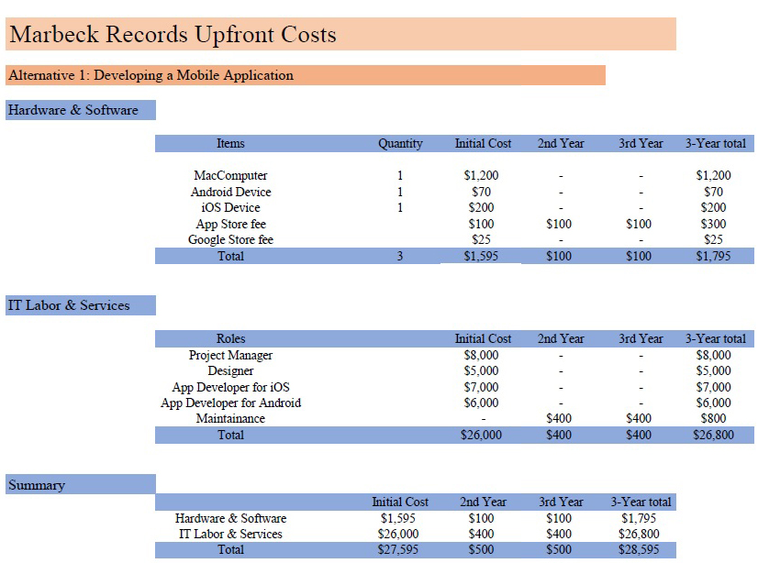

Image 6: Upfront cost for Alternative 1

Alternative 2: Migrating the current website to cloud technology

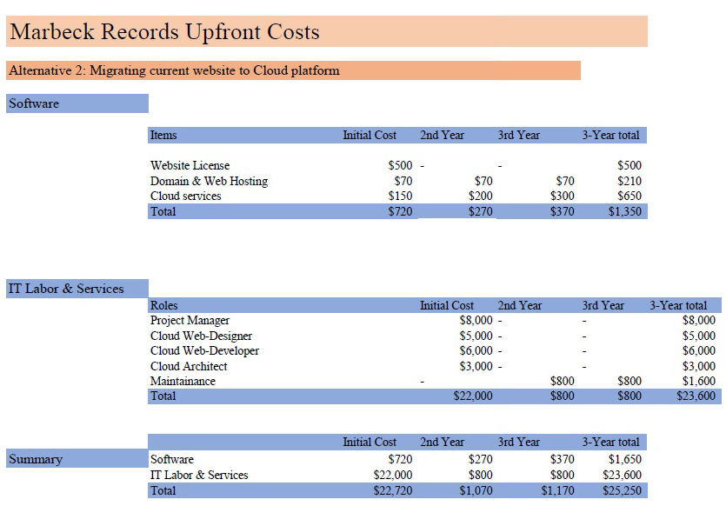

Image 7: Upfront cost for Alternative 2

Alternative 3: Reengineer the current website

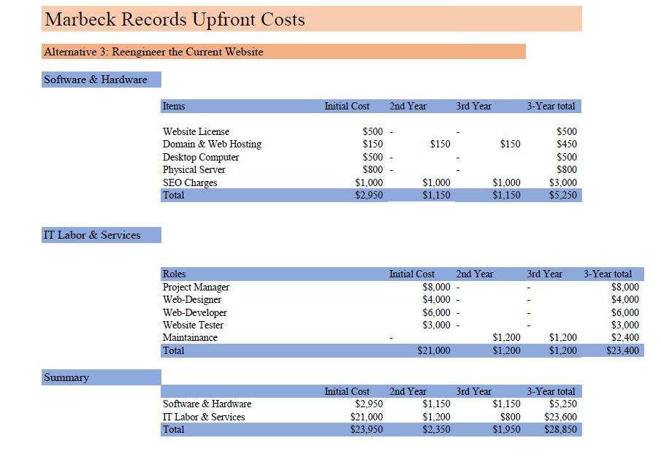

Image 8: Upfront cost for Alternative 3

# **APPENDIX B**

The following images will explain the revenue and benefits of each alternatives.

Alternative 1: Creating a mobile application

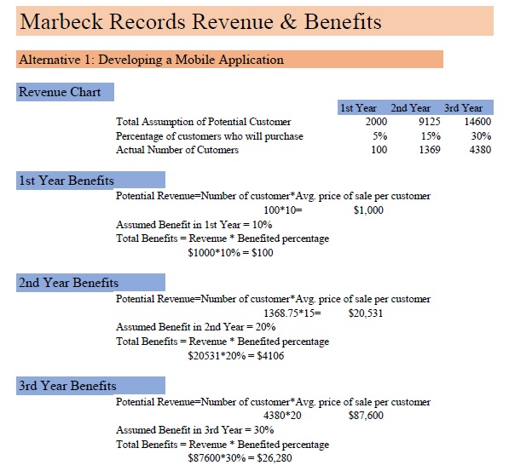

Image 9: Revenue & Benefits or Alternative 1

Alternative 2: Migrating the current website to cloud technology

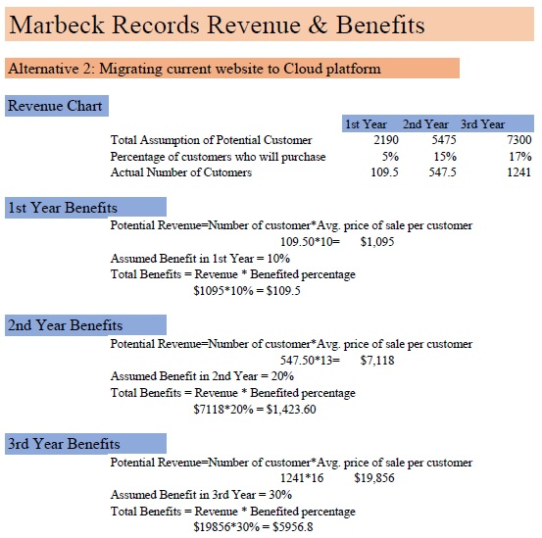

Image 10: Revenue & Benefits or Alternative 2

Alternative 3: Reengineer the current website

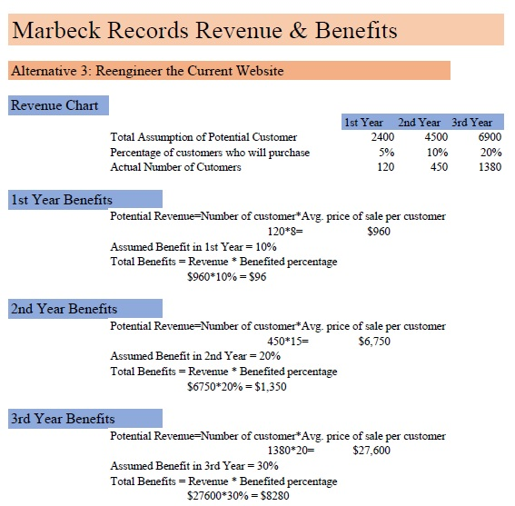

Image 11: Revenue & Benefits or Alternative 3

# **APPENDIX C**

Alternative 1: Creating a mobile application

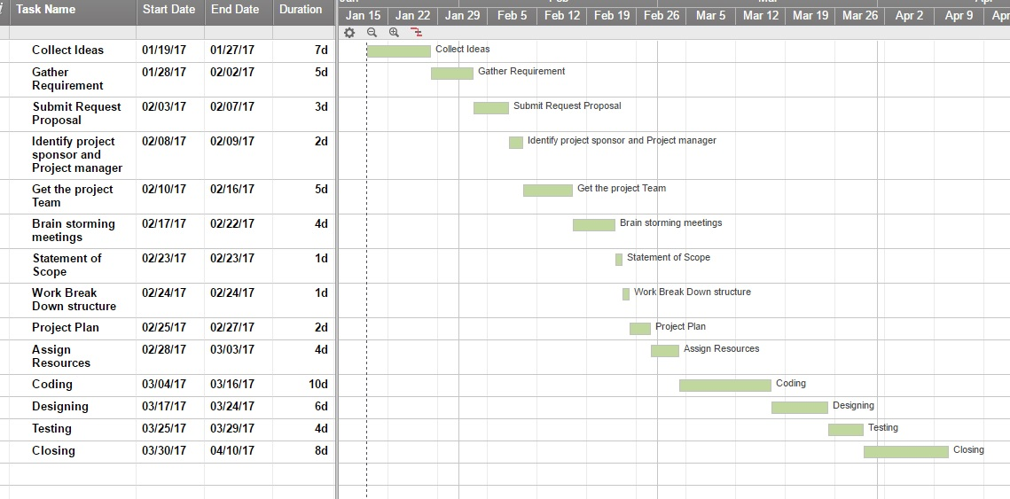

Image 12: Gantt chart for Alternative 1

Alternative 2: Migrating the current website to cloud technology

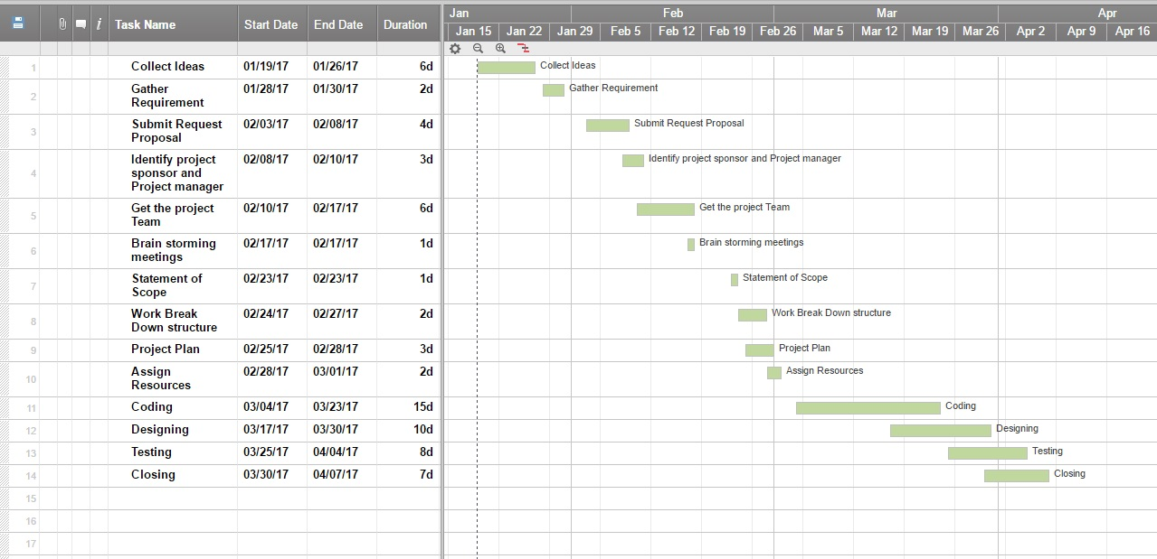

Image 13: Gantt chart for Alternative 2

Alternative 3: Reengineer the current website

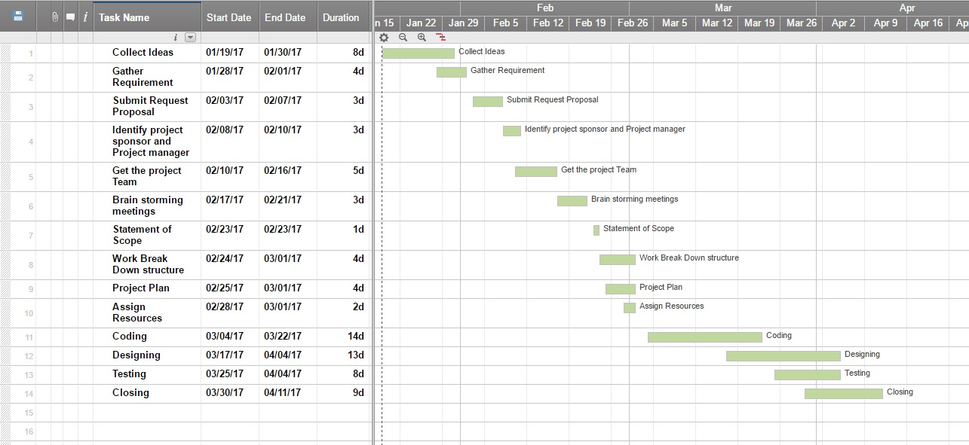

Image 14: Gantt chart for Alternative 3